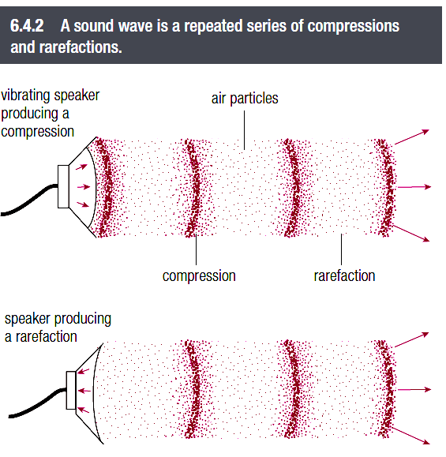
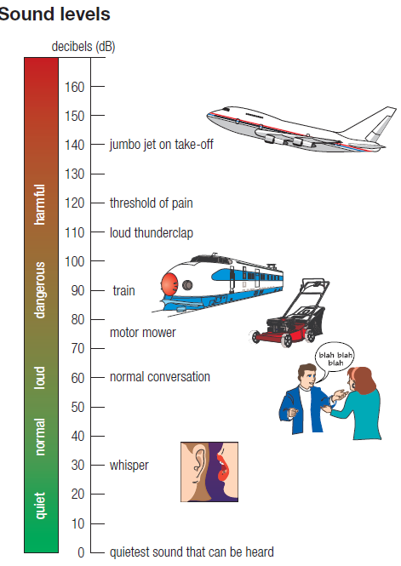
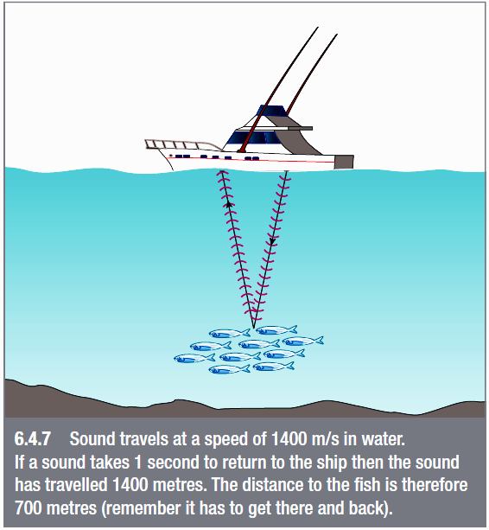

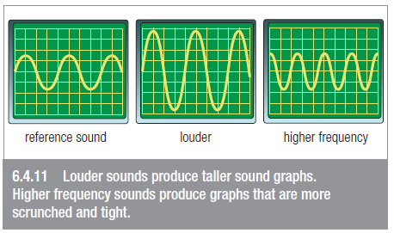

Questions
1. What is meant by the frequency of a sound?
2. At what dB: a is normal conversation b is pain felt?
3. Explain why we can’t hear the nuclear explosions on the Sun.
4. In old cowboy fi lms, Indians could tell if buffalo were approaching by placing their ear on the ground. Suggest how this helps.
5. In air at 20ºC, how far would sound travel in: a 1 second b 3 seconds c 1 minute?
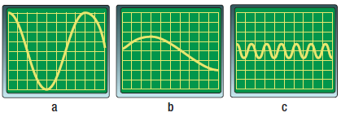
6. Which of the displays on the right was caused by:
a the loudest sound
b the highest frequency sound?

